# A Project Report



# on

**POWER SYSTEM FAULT DIAGNOSIS USING**

**MACHINE LEARNING**

# *submitted in partial fulfilment of requirements for the award of the degree of*

BACHELOR OF TECHNOLOGY

*in*

# ELECTRICAL AND ELECTRONICS ENGINEERING

*by*

|  |  |
| --- | --- |
| **EDAGOTTI PAVANKUMAR** | **16121A0253** |
| **AVILALA DEDEEPYA** | **16121A0208** |
| **GAYAKAWADA CHANDRASEKHAR** | **16121A0265** |
| **AVULA PRAVALIKA** | **16121A0209** |

*under the guidance of*

# Dr. S. HEMACHANDRA *M.Tech., Ph.D*

# Professor



**DEPARTMENT OF ELECTRICAL AND ELECTRONICS ENGINEERING**

**SREE VIDYANIKETHAN ENGINEERING COLLEGE**

**(AUTONOMOUS)**

## **RANGAMPET, TIRUPATI – 517 102**

**INDIA**

**2019 - 2020**

**SREE VIDYANIKETHAN ENGINEERING COLLEGE**

(An Autonomous institution affiliated to JNTUA, Ananthapur)

Sree Sainath Nagar, Tirupati-517 102.

**DEPARTMENT OF ELECTRICAL AND ELECTRONICS ENGINEERING**



**CERTIFICATE**

This is to certify that the report on the Project entitled “**POWER SYSTEM FAULT DIAGNOSIS USING MACHINE LEARNING**” submitted by

|  |  |
| --- | --- |
| **EDAGOTTI PAVANKUMAR** | **16121A0253** |
| **AVILALA DEDEEPYA** | **16121A0208** |
| **GAYAKAWADA CHANDRASEKHAR** | **16121A0265** |
| **AVULA PRAVALIKA** | **16121A0209** |

to Department of EEE, Sree Vidyanikethan Engineering College, an autonomous institution affiliated to Jawaharlal Nehru Technological University Anantapur, in partial fulfilment of the requirements for award of degree of **Bachelor of Technology** in **Electrical and Electronics Engineering**, is a bonafide work carried out and submitted by them under my supervision.

|  |  |
| --- | --- |
| **Supervisor:**  **Dr. S. HEMACHANDRA, *M.Tech., Ph.D.***  Professor  Department of EEE  Sree Vidyanikethan Engineering College  A. Rangampet.  **EXAMINER – 1** | **HOD:**  **Dr. M. S. SUJATHA, *M.Tech., Ph.D.***  Professor  Department of EEE  Sree Vidyanikethan Engineering College  A. Rangampet.  **EXAMINER - 2** |

Declaration

We hereby declare that the Project report on “POWER SYSTEM FAULT DIAGNOSIS USING MACHINE LEARNING” has been submitted by us under the guidance and supervision of Dr S.Hemachandra Professor, Department of Electrical and Electronics Engineering, Sree Vidyanikethan Engineering College, Tirupati. This work / report has not been submitted either for the award of any degree or any other similar title.

|  |  |
| --- | --- |
| **EDAGOTTI PAVANKUMAR** | **16121A0253** |
| **AVILALA DEDEEPYA** | **16121A0208** |
| **GAYAKAWADA CHANDRASEKHAR** | **16121A0265** |
| **AVULA PRAVALIKA** | **16121A0209** |

**ACKNOWLEDGEMENTS**

We would like to express my profound sense of gratitude to **Dr. S. HEMACHANDRA M.Tech., Ph.D., Professor, Department of EEE** for his valuable guidance and constructive suggestions made at various levels of the work.

We are thankful to **Dr. M. S. SUJATHA, M.Tech., Ph.D., Professor and HOD, Department of Electrical and Electronics Engineering,** for her guidance, constant encouragement and support.

We express my gratitude to beloved Principal **Dr. P.C. KRISHNAMACHARY, M.Tech., Ph.D.,** and the **Management** of SVEC for providing all the facilities in completing Seminar course successfully. My heartfelt thanks to all my **Teachers** in the department of **EEE** of Sree Vidyanikethan Engineering College for their moral support and good wishes.

Finally, we would like to express my sincere thanks to our parents, friends, one and all those who guided, inspired and helped me in completion of my Seminar course work.

|  |  |
| --- | --- |
| **EDAGOTTI PAVANKUMAR** | **16121A0253** |
| **AVILALA DEDEEPYA** | **16121A0208** |
| **GAYAKAWADA CHANDRASEKHAR** | **16121A0265** |
| **AVULA PRAVALIKA** | **16121A0209** |

**ABSTRACT**:

The power system is very important asset for every nation. In recent days we are very much dependent on electric power. Electric power consumption is the key index of nations development. Power systems has challenges such as fault diagnosis, load frequency control, unit commitment, load scheduling, optimization, etc. In the above-mentioned, fault diagnosis is one of the major issue. The stability of the power system depends on the faults in the system. If any fault occurs in the system means the corrective measure has to be taken within a few seconds else losses in the system will get increased and also the equipment in the power system will get damaged. These issues in fault diagnosis can be addressed with various traditional and artificial intelligence-based techniques.

Machine Learning is one of the better technique available for the above-mentioned issue. Machine learning uses artificial neural networks to process the data. Artificial neural networks are inspired by the human brain. These neural networks are shown to be in layers. There will be multiple layers to process the data. The output from one layer is used as input for another layer. This network structure is called as artificial neural network. Before testing the network, the training for the network is essential by using past data.

In this thesis, we will try to address the power system fault diagnosis problem, by exploring various machine learning techniques. The simulation results concluded that partially Recurrent network is efficient in detecting and classifying the faults on transmission lines with satisfactory performance.

**LIST OF CONTENTS:**

Abstract..................................................................................................................................

List of Contents.......................................................................................................................

List of Figures..........................................................................................................................8

List of Tables ...........................................................................................................................9

**Chapter 1: Significance and Basics of Power System** ............................................................10

1.1 Introduction ....................................................................................................................10

1.2 Power System Faults.........................................................................................................11

1.2.1 Series Faults……………………………………………………………..……………………………………………….11

1.2.2 Shunt Faults………………………………………………………………………………………………………..…….11

1.3 Causes of Electrical Faults.................................................................................................11

1.4 Survey of Methods………………………………………..…………………………………..………………………...11

1.5 Problem Statement ..........................................................................................................11

**Chapter 2: Artificial Neural Network**.....................................................................................11

2.1 Introduction to ANN .........................................................................................................11

2.2 Importance and Learning Techniques of ANN..................................................................11

2.2.1Importance....................................................................................................................11

2.2.2 Learning Techniques.....................................................................................................11

2.3 Characteristics and Applications of ANN...........................................................................11

2.3.1 Characteristics……………………………………..........................................................................11

2.3.2 Applications…………………………………….............................................................................11

2.4 Advantages and Disadvantages of ANN............................................................................11

2.4.1 Advantages………………………………………………………………………………………………………………..11

2.4.2 Disadvantages……………………………………………………………………………………………………………11

**Chapter 3: Deep Neural Network** ..........................................................................................11

3.1 Introduction ......................................................................................................................11

3.2 Recurrent Neural Network ...............................................................................................11

3.3 Training of RNN…………………………………………………………………………………………………………..11

3.4 Advantages of RNN……………………………………………………………………………………………………….11

3.5 Disadvantages of RNN…………………………………………………………………………………………………..11

**Chapter 4: Simulation Results**……………..................................................................................11

**Chapter 5: Conclusion**.............................................................................................................11

5.1 Summary and Findings .....................................................................................................11

**LIST OF FIGURES:**

Figure 1: Structure of Power System………………………………………………………………………………….11

Figure 2: Classification of Short Circuit Faults…………………………………………………………………….11

Figure 3: Fault Classification and Location Techniques……………………………………………………….11

Figure 4: Structure of ANN………………………………………………………………………………………………….11

Figure 5: Studied System with Sources at Both Ends………………………………………………………….11

Figure 6: Artificial Neural Network…………………………………………………………………………………….11

Figure 7: A Biological Neuron……………………………………………………………………………………………..11

Figure 8: Perceptron…………………………………………………………………………………………………………..11

Figure 9: Deep Neural Network………………………………………………………………………………………….11

Figure 10: Performance of Deep Learning…………………………………………………………………………11

Figure 11: Recurrent Neural Network…………………………………………………………………………………11

Figure 12: Recurrent Neural Network with weights and biases………………………………………..…11

Figure 13: RNN

Figure 14:

Figure 15:

**LIST OF TABLES:**

Table 1:

Table 2:

Table 3:

Table 4:

Table 5:

Table 6:

Table 7:

Table 8:

Table 9:

**CHAPTER 1**

**SIGNIFICANCE AND BASICS OF POWER SYSTEM**

* 1. **INTRODUCTION:**

Electrical power systems is an important asset of every nation. Our society requires power for so many things which include healthcare, transportation, industrial manufacturing etc. The power systems were grown very rapidly in the past few decades that resulted in a large increase in the number of lines in operation and their length. The structure of power system consists of generation, distribution and transmission system. It consists of generating stations that produce electrical power, [high voltage transmission lines](https://en.wikipedia.org/wiki/High_voltage_transmission_line) that carry [power](https://en.wikipedia.org/wiki/Power_(physics)) from distant sources to demand centres and distribution lines that connect individual [customers.](https://en.wikipedia.org/wiki/Customer) Transmission lines plays an important role in electrical distribution system, as it provides path to transfer power between generation and load. The transmission lines are exposed to open environment so that the faults are unavoidable. These faults as a result of lightning, short circuits, faulty equipment, Miss-operation, human errors, overloading and ageing etc.

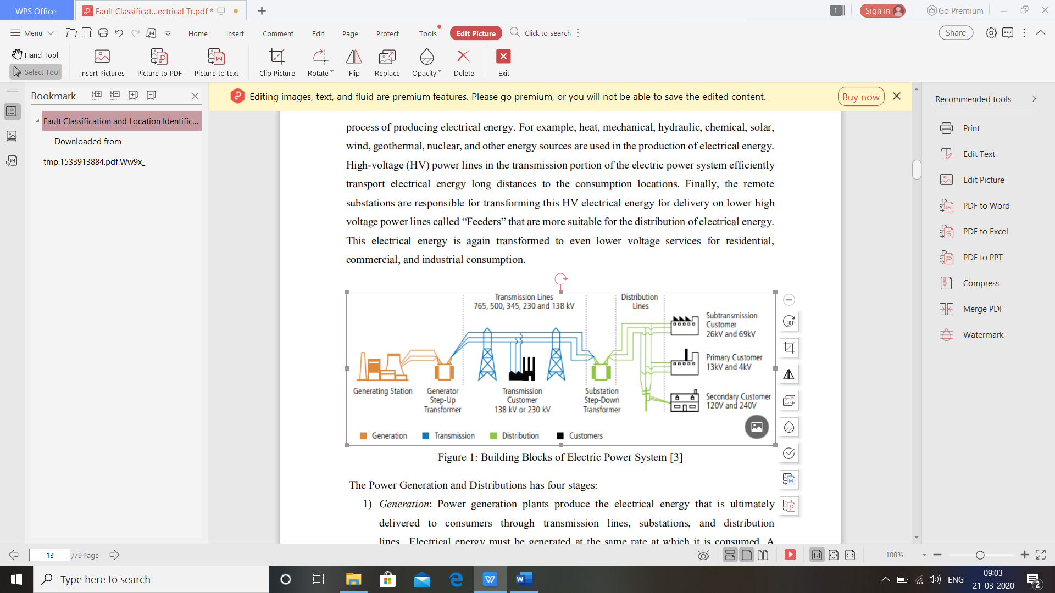

**Figure 1: Structure of power system**

When a fault occurs in transmission line it is very important to detect, classify and to find the fault location to restore the power delivery.85% of power system faults occur on distribution lines. However, the faults that occur on the transmission lines are rare but they have a significant impact on the consumers. The performance of a power system is affected by faults on transmission lines, which results in interruption of power flow. There pair and restoration of supply voltage is essential for minimizing economic impacts, reducing overall power outages and improving customer satisfaction.

Most of the faults can cause large currents or voltage changes so that they can be detected using the traditional protective relays. But some faults, such as high impedance faults will cause small current and voltage changes. So that it is difficult to detect by a traditional protective relay. For those problems, we need an efficient fault detection, classification and location methods.

**1.2 Power System Faults:**

Fault is an abnormal condition in the electrical systems. The faults in the electric transmission lines are short circuit faults and open circuit faults etc. Open circuit faults are very rare in the transmission lines but the short circuit faults are very common these faults are may be due to natural climatic conditions and mis-operation.

**1.2.1 SERIES FAULTS:**

Series faults represent open conductor and take place when unbalanced series impedance conditions of the lines are present. These faults disturb the symmetry in one or two phases and are therefore unbalanced faults. Series faults are characterized by increase of voltage and frequency and fall in current in the faulted phases.

**1.2.2 SHUNT FAULTS:**

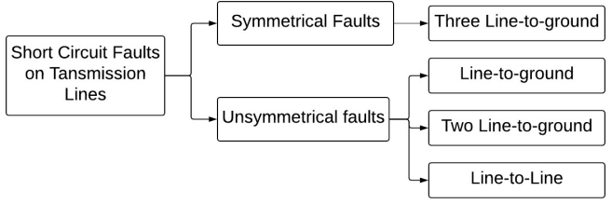

**Figure 2: Classification of Short Circuit faults**

There are two types of shunt faults which can occur on transmission lines; balanced faults and unbalanced faults also known as symmetrical and unsymmetrical faults. The shunt faults are the most common type of fault taking place in the field. They involve power conductors or conductor-to-ground or short circuits between conductors. In shunt faults increment the current suffers fall in voltage and increase frequency.

**SYMMETRICAL FAULTS:**

Symmetrical faults are most severe faults and rarely occurs in the power system. These faults are balanced. These faults are of two types LLL fault and LLL-G faults, When ground involves in the fault then that is called as LLL-G fault else called as LLL fault. The analysis can be done by using per phase.

**UNSYMMETRICAL FAULTS:**

These faults are very common and less severe than the symmetrical faults. These faults are classified as the line to ground (L-G), line to line (L-L), double line to ground fault (LL-G) faults. These faults are unbalanced in nature and cause unbalanced currents to flow in the phases. The study of un-symmetrical faults can be done by using symmetrical components.

**Line-to-ground fault:**

when one phase of transmission line comes in contact with the ground either by ice, wind, falling tree or any other incident results in L-G fault. About 70% of the faults in the transmission lines comes under this category. It causes the conductor to make contact with earth or ground.

**Line-to-line fault:**

During heavy winds, one phase could touch other phase which results in line-to-line fault. Approximately 15% of all transmission lines faults are line-to-line faults. Line to line faults occur when two conductors make contact with each other mainly while swinging of lines due to winds. These are also called unbalanced faults since their occurrence causes unbalance in the system.

**Double line-to-ground:**

when two phases comes in contact with the ground it will lead to this type of fault. Two phases will be involved instead of one in the line-to-ground fault condition. 15 to 20 percent of faults in the transmission lines are double line to ground faults.

**1.3 Causes of Electrical Faults**

• **Climatic conditions:** It includes lighting strikes, heavy rains, heavy winds, salt deposition on overhead lines and conductors, snow and ice accumulation on transmission lines, etc. These environmental conditions interrupt the power supply and also damage electrical installations.

**• Failure of equipment:** Electrical equipments like [generators](https://www.elprocus.com/working-of-generators/" \t "_blank), motors, transformers, reactors, switching devices.. etc causes short circuit faults due to malfunctioning, ageing, insulation failure of cables and winding. These failures result in high current to flow through the devices or equipment which further damages it.

• **Human errors:** Electrical faults are also caused due to human errors such as selecting improper rating of equipment or devices, forgetting metallic or electrical conducting parts after servicing or maintenance, switching the circuit while it is under servicing, etc.

• **Fires:** Ionization of air, due to smoke particles, surrounding the overhead lines results in spark between the lines or between conductors to insulator. This flashover causes insulators to lose their insulting capacity due to high voltages.

**1.4 Survey of methods:**

Some of the effects of faults are tripping of relays, damaging insulation, threat to individuals working there, improper working of equipment, flashovers and sparks due to short circuit. so, it is necessary to detect and classify the faults and its location to overcome all the effects of faults and to maintain continuity in the power supply. Some of the fault classification and location identification techniques in transmission lines by machine learning methods were shown below.

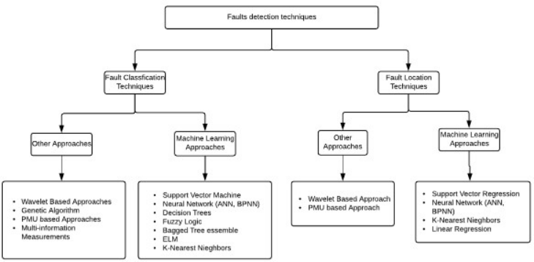

**Figure 3: Fault classification and location techniques**

The survey is mainly divided into two parts:

1. Fault classification techniques - Methods that determine the fault type
2. Fault Location Techniques - Methods that calculate the distance of the fault

Both techniques play a vital role in development of protection mechanisms for a given power system model. There are plenty of techniques proposed over the past years. Those techniques have their advantages and disadvantages. The fault classification and location identification must be very fast to improve power quality.

**1.Fault classification Techniques:**

**A. Discrete Wavelet Transform:**

Discrete wavelet Transform (DWT) is a very important technique for the feature extraction from certain frequency bands in signals. Discrete wavelet transforms with Multi-Resolution Analysis (MRA) can be used to analyse the high-frequency signals for a short duration. The main drawbacks of DWT are the choice if appropriate mother function suitable for the application, computational complexity and time etc.

**B. Artificial Neural Networks**:

Artificial neural networks are (ANN) are a family of non-linear statistical models and learning

algorithms that are intended to imitate the behaviour of connected neurons in biological neural systems. Different ANN models have been used for different applications. Feedforward neural network (FNN) the simplest neural network configuration which can be characterized as a single layer or Multi-Layer-Perceptron. An FNN often has an input layer, output layer and at least one hidden layer. The node or neurons will fully be connected with adjacent layer to process in data. The weights will be assigned and the bias for the nodes decides the output of the network given an input.

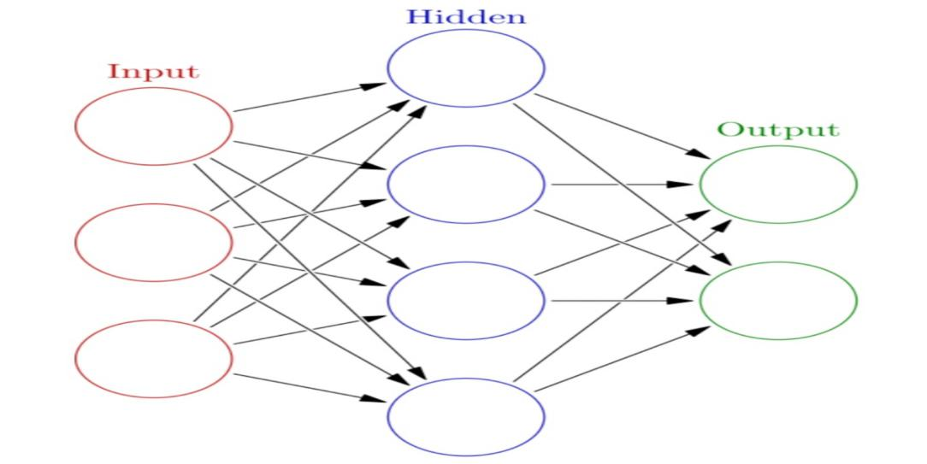

Fig 4: Structure of Artificial neural network

Fig. 1 shows the artificial neural network with multi-input and a single output. From the late 1980’s researchers are using Back-propagation algorithm with FNN. There are several types of FNN networks such as Radial basis function networks (RBFN), Probabilistic neural networks (PNN) etc.

**C. Support Vector Machines:**

Support vector machine (SVM) was invented by Cortes and Vapnik in 1995. The main idea of

SVM classifiers is to find the optimal hyperplane that maximizes the margin between two groups of examples. SVM uses non-linear kernel functions to map the examples into higher dimensions. SVM prevents overfitting due to its structural risk-minimizing nature. SVM is a very powerful tool for classification problems. SVM with other techniques were also implemented such as DWT, ST etc. Even though SVM gives better results, it has a problem with parameter optimization.

**D. Decision Trees**:

Decision Trees (DT’s) refers to the class of tree-like graphs capable of decision making. DTs

will look like trees models with nodes. Concretely, three types of nodes found in a DT, namely root node, internal nodes and leaf nodes. Decision-making starts from the root node and the flow goes along the path that satisfies the test conditions. Decision trees can be trained with many algorithms such as greedy algorithm, random forest etc. Decision trees are easy to understand by humans as per the conditions, but the main drawback is their stability.

**2. Fault Location Identification Techniques**:

The accurate location of faults in the transmission lines and distribution system greatly reduces the time to restore the power. The conventional fault location methods can be classified into two groups, Travelling Wave-Based Schemes and Impedance Measurement Based Schemes.

**A) Travelling Wave Based Fault Locators:**

Travelling waves will get generated due to switching operations and faults such as short circuit

faults and open circuit faults. Travelling waves phenomenon for fault location is classified into four different types. Two of them are generated wave analysis and the remaining two are external wave injection to the transmission line at a single end and both ends. The time of reflection of the wave is proportional to the fault location.

**B) Impedance Measurement Based Fault Locators:**

These schemes provide another alternative for the fault location estimation problem. Let us

consider that a single line to ground fault occurred in a transmission line with a fault resistance at a distance x from the sending end. The fault will draw the fault current based on the fault resistance. The measurements units which are placed at sending end and receiving end will measure currents and voltages for double end algorithms, for single-end algorithms measurement will be done at sending end only.

**C) Other Fault Locators:**

The above-mentioned techniques are normal mathematical derivations, instead of conventional fault location techniques soft computing techniques such as wavelet transform, artificial neural networks or genetic algorithms were also introduced. But these methods have their problems that result from the line modelling accuracy, data availability.

**1.5 Problem statement**

Let us consider a simple three phase network with two sources. The line to line voltage is 200kv and length of the transmission line is 200 km with frequency 50Hz.

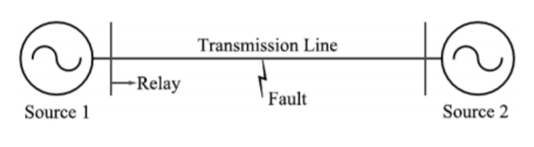 Figure 5: Studied System with Sources at both ends

Z1 = 4.76 + j\*59.75 ohmsZ0 = 77.70 + j\*204.26 ohmsFault Types: a-g, b-g, c-g, a-b, b-c, a-c, a-b-g, b-c-g, a-c-g, a-b-c, no faultFault Resistance: 0.001, 5 ,10, 15,20 ohmsFault Location: 0,50,100,150,200 kms

**CHAPTER 2**

**ARTIFICIAL NEURAL NETWORKS**

**2.1: INTRODUCTION TO ARTIFICIAL NEURAL NETWORKS:**

ANN is an information processing paradigm that is inspired by the way of biological nervous system such as human brain processes the information. It is composed of large number of highly interconnected processing elements [Neurons] working together to solve a specific problem. AN ANN comprises, of different layers-

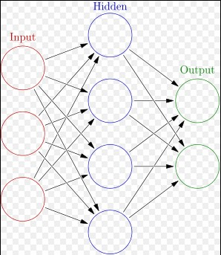

**Figure 6: Artificial Neural network**

**Input layer:**

It contains neurons which receive input from the outside world on which network will learn and process.

**Hidden layer:**

It is situated in between input and output layer. The main purpose of hidden layer is to transform the input into something which is then utilized by the output layer.

**Output layer:**

It contains the units that will respond to the information about how it’s learned any task.

On the other hand, ANN contains

1) Neurons

2) Activation functions

**NEURONS:**

Biological neurons also called as nerve cells or simply neurons are the fundamental units of the brain and nervous system, the cells are responsible for receiving sensory input from the external world via dendrites, and gives output through the axons.

**CELL BODY:**

The body of the neuron cell contains the nucleus and carry out biochemical transformation necessary to the life of neurons.

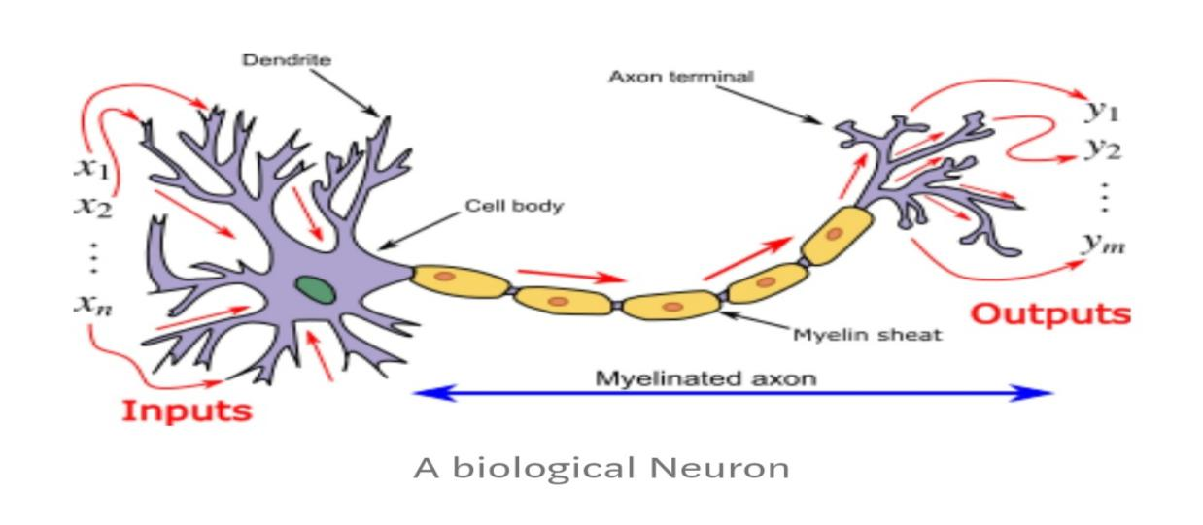

Figure 7: A biological Neuron

**DENDRITES:**

Each neuron has fine hair like sigmoid structures. They branch out in around the cell body and also accept the incoming signals.

**AXON:**

It is a long thin tabular structure that works like a transmission line.

**SYNAPSE:**

Neurons are connected to one another in a complex spatial arrangement. When axons reached its final destination it branches again called terminal arborization. The end of the axons has highly complex and specialized structures called synapse. The connection between two neurons takes place at these synapses.

Dendrites receive input through the synapse of other neurons. The processes these incoming signals overtime and coverts that processed value in to an output, which is sent out to other neurons through the axons and synapses.

The following diagram represents the general model of ANN which is inspired by biological neuron. It is also called perceptron and gives single output.

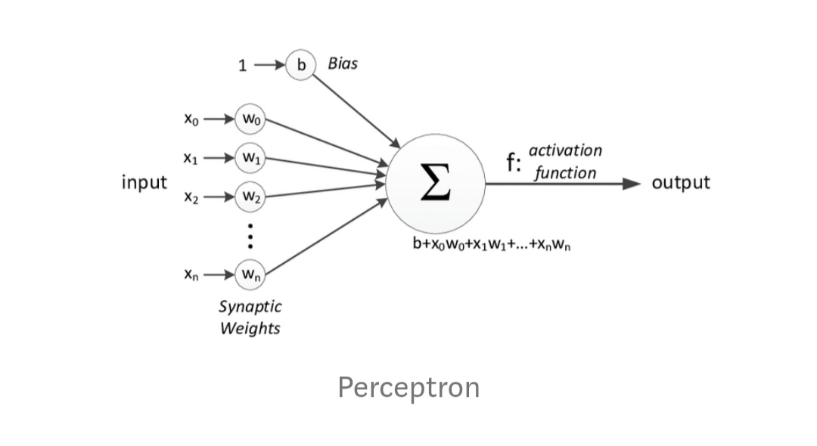

**Figure 8: Perceptron**

In the above figure, for one single observation X0, X1, X2, X3………X(n) represents various inputs [independent variables] to the network. Each of these connections are multiplied by α connection weight or synapse. The weights are represented as W0, W1, W2, W3, ……..W(n).Weight denote the length of a particular node.

b is a bias value. A bias value allows you to shift activation function up or down. In the simplest case, these products are summed and fed to a Transfer function (Activation function) to generate α results. These results are sent as outputs.

Mathematically X1 W1+X2 W2+X3 W3…………+X(n) W(n) = ∑ X(i) W(i).

**ACTIVATION FUNCTION:**

The activation function is very important to an ANN to learn and make sense of something really complicated. Their main purpose is to convert an input signal of a node in an ANN to an output signal. The output signal is used as input to the next layer in the stack.

Activation function decides whether a neuron should be activated or not by evaluating the weighted sum and adding bias to it. The main motive is to introduce non-linearity into the output of the neuron. Suppose if we do not apply activation function then the output signal would be simply linear function. Now, a linear function is easy to solve because of less complexity and require less power. There are different types of activation functions. some of them are

1)Threshold Activation function

2)Sigmoid Activation function

3) Hyperbolic tangent function

**2.2 IMPORTANCE AND LEARNING TECHNIQUES OF ANN:**

**2.2.1 IMPORTANCE:**

Artificial neural network can be applied to fault detection, classification and fault location in power system effectively because it is a programming technique, capable of solving non-linear data easily. The problem in which the information available is in massive form it can be dealt with ANN. Also, the ANN is able to learn with experiences. They are widely accepted and used in the problem of fault detection, classification and fault location due to the following features:

* The Number of transmission line configurations are possible from short length, long length, single circuit transmission line to double circuit transmission line etc.
* There are several methods to stimulate the network with different power system condition in fast and reliable manner.
* The condition of the electrical power system will change after each and every disturbance. Hence, a neural network is capable to incorporate the dynamic changes in the power system.
* The ANN output is very fast, reliable and accurate depending on the training of data, because its working depends upon a series of simple operations.

**2.2.2 LEARNING TECHNIQUES:**

Learning or training is basically adjustment of weights in order to achieve the required target. Learning of neural network can be done by:

1. Forming new connection
2. Deleting existing connections
3. Adjusting connection weights
4. Adjusting the neurons threshold values
5. Developing new neurons
6. Removing existing neurons

Among the above mentioned, methods changing the weights is the most commonly used method. Three important methods of learning are

* Unsupervised Learning (provides input pattern)
* Supervised Learning (provides training pattern with desired output)
* Reinforcement Learning method (provides feedback to the network)

In Supervised Learning both input and desired output is known prior to training of Neural network where as in Unsupervised Learning we do not know the exact association between input and output. We train the ANN with the known input values, so it is very important to select the suitable values for the better training of network. Two, well known Unsupervised Learning Algorithms are Adoptive Resonance Theory (ARP) and Self Organized Map (SOP). Because of the non-linear behavior of activation function, a numerical method is required to solve non-linearity's. The Backpropagation method is based on the steepest decent approach and is extensively used for training known as LEVENBERG -MARQUARDT Algorithm.

**2.3 CHARACTERISTICS AND APPLICATIONS OF ANN:**

**2.3.1 CHARACTERISTICS OF ANN:**

Artificial neural network irrespective of style and logic if implementation has a few basic characteristics. some of them are mentioned below

* Artificial neural network consists of large number of “neurons” as processing elements.
* All these processing elements have a large number of weighted connections between them
* The connections between the elements provide a distributed representation of data.
* A learning process is implemented to acquire knowledge.

**2.3.2 APPLICATIONS OF ANN:**

They have many applications such as classification, language generation, question answering, information extraction, speech and image processing etc. some of them are discussed below

**APPLICATIONS IN SPEECH:**

* Vowel classification
* Recognition of vowel-constants segments
* Recognition of stop consonant-vowel utterances in Indian language
* Phonetic type writer

**APPLICATIONS IN IMAGE PROCESSING:**

* Recognition of symbols (used in Olympics)
* Recognition of handwriting
* Segmentation of image
* Classification and segment of texture

**TIME SERIES PREDICTION:**

We use ANN to predict the future stocks, natural calamities using previous data.

**MILITARY AND AEROSPACE:**

Generally, ANN is used in autopilot aircrafts for fault detections and in military for target tracking, steering, weapon orientation etc.

**2.4 ADVANTAGES AND DISADVANTAGES OF ANN:**

**2.4.1 ADVANTAGES OF ANN:**

**STORING INFORMATION ON THE ENTIRE NETWORK:**

Information in traditional programming is stored on the entire network, not on a database. The disappearance of few pieces of data in one place does not prevent the network from functioning.

**ABILITY TO WORK WITH COMPLETE KNOWLEDGE:**

After training the ANN, the data may produce output even without complete information. The loss of performance here depends on the importance of missing information.

**HAVING FAULT TOLERANCE:**

Corruption of one or more cells of ANN does not prevent it from generating output. This feature makes the networks fault tolerant.

**PARELLEL PROCESSING CAPABILITY:**

ANN have numerical strength so, it can perform more than one task at the same given time.

**2.4.2 DISADVANTAGES OF ANN:**

**HARDWARE DEPENDENCE:**

Artificial neural networks require processors with parallel processing power in accordance to their structure. For this reason, the realization of the equipment is dependent.

**UNEXPLAINED BEHAVIOR OF THE NETWORK:**

This is the most important problem of ANN. When ANN is probing solution it doesn’t give a clue as to why and how. This reduces the trust in the network.

**DETERMINATION OF PROPER NETWORK SOLUTION:**

There is no specific rule for determining the structure of ANN. Appropriate network structure is achieved through the experience and trial and error.

**AMOUNT OF DATA:**

There is no improvement in performance of ANN with large amount of data.

**CHAPTER 3**

**DEEP NEURAL NETWORKS**

**3.1 INTRODUCTION TO DEEP NEURAL NETWORKS:**

Deep Learning is the most exciting and powerful branch of machine learning. Deep Neural network is also an Artificial neural network with multiple hidden layers in between input and output layer. If there is more than one or two hidden layers then it is often referred as Deep Neural network. Deep learning models can be used for a variety of complex tasks.

* Artificial Neural Network for Regression and Classification
* Convolutional Neural Network for Computer Vision
* Recurrent Neural Network for Time Series Prediction
* Self- Organizing Maps for Future Extraction.

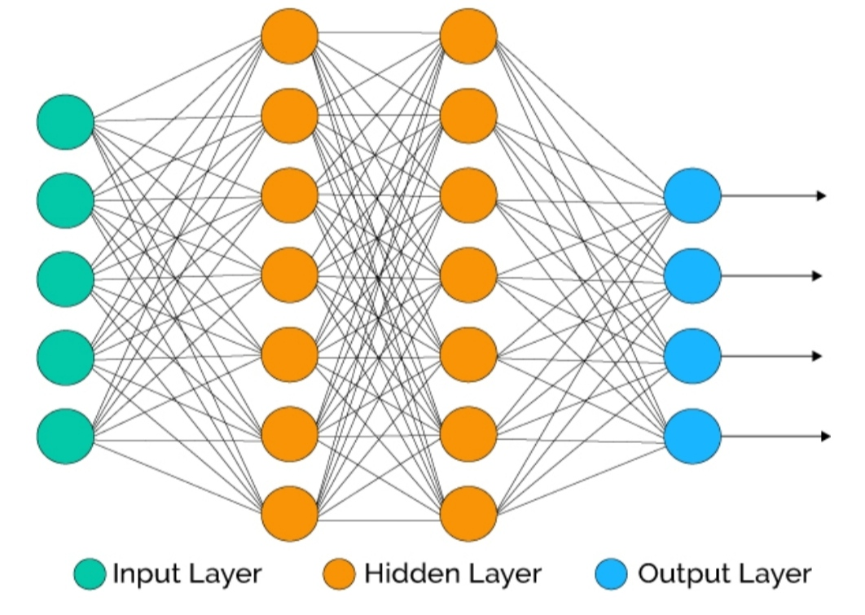

**Figure 9: Deep Neural Network**

To overcome the drawbacks of ANN we are going for DNN. In Deep Learning, a computer model learns to perform classification tasks directly from image, text, or sound. It achieves the state of art accuracy, sometimes exceeding human level performance. Models are trained by adding a large set of labeled data and neural network architectures that contain many layers.

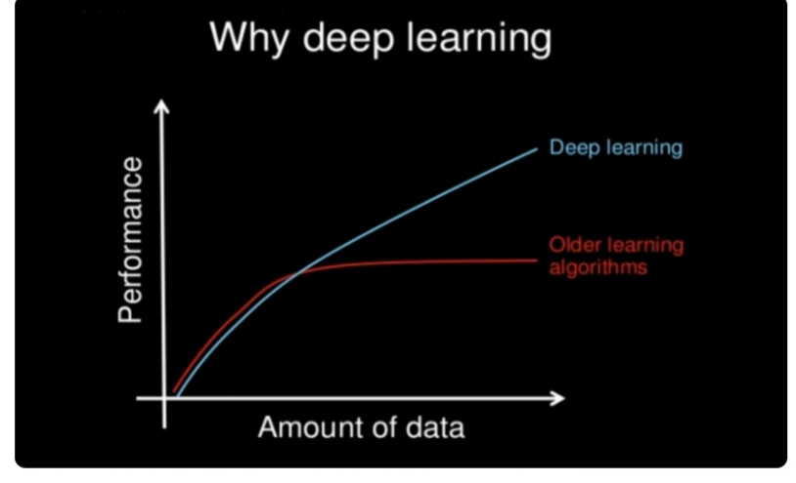

**Figure 10: Performance of Deep learning**

The performance of Deep neural network is more effective as the amount of data gets increased compared to other old traditional neural networks. There are different types of neural networks. But here were mainly concentrating on Recurrent Neural Network.

**3.2 RECURRENT NEURAL NETWORK:**

Recurrent neural network is a type of network in which the output from previous step is fed as input to the current step. In traditional neural network all the inputs and outputs are independent of each other; But in cases like when it is required to predict the next word of a sentence, the previous words are required and hence there is a need to remember the previous words, this is how the RNN came in to existence. which solved this issue with the help of the hidden layer. The main and most important feature of RNN is hidden state, which remembers some information about a sequence.

**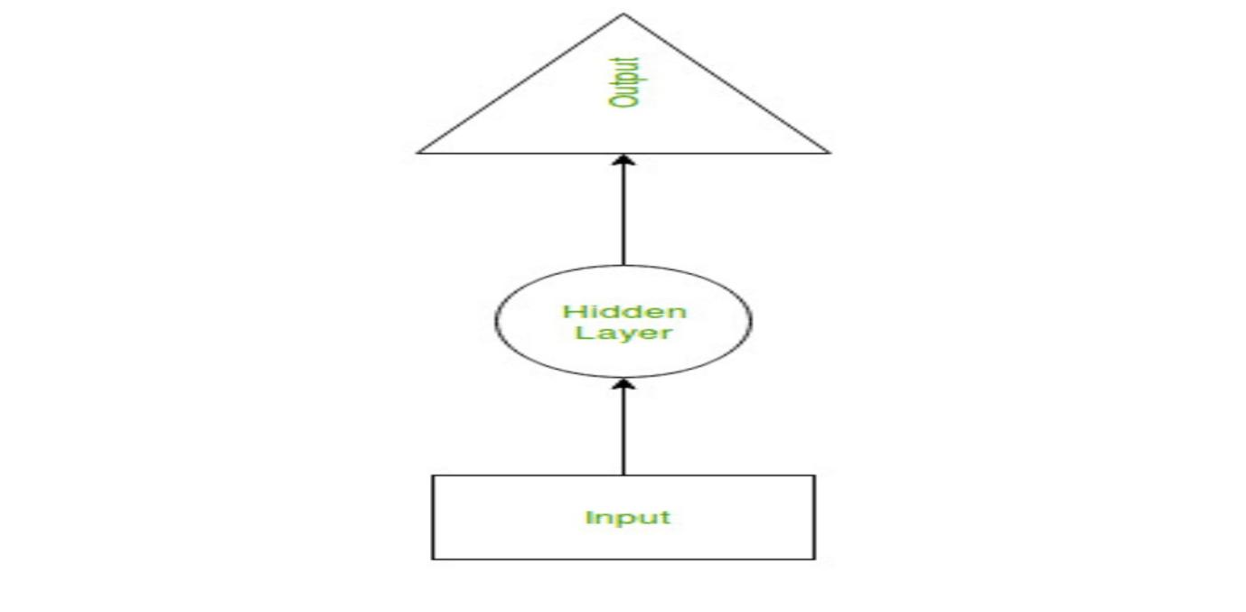**

Figure 11: Recurrent Neural Network

RNN have a memory which remember all information about what have been calculated. It uses the same parameters for each input as it performs the same task on the all inputs (or) hidden layers to produce the outputs. This reduces the complexity of parameters, unlike other neural networks.

**WORKING OF RNN**:

The working of RNN can be understood with the help of a example. Suppose there is a deeper network with one input layer, three hidden layers, and one output layer.

Then like other neural network each hidden layer will have its own set of weights and biases. Let’s say for hidden layer one the weights and biases are (W1, B1), (W2, B2) for second hidden layer and (W3, B3) for third hidden layer. This means that each of these layers are independent of each other. Therefore, do not memorize the previous outputs.

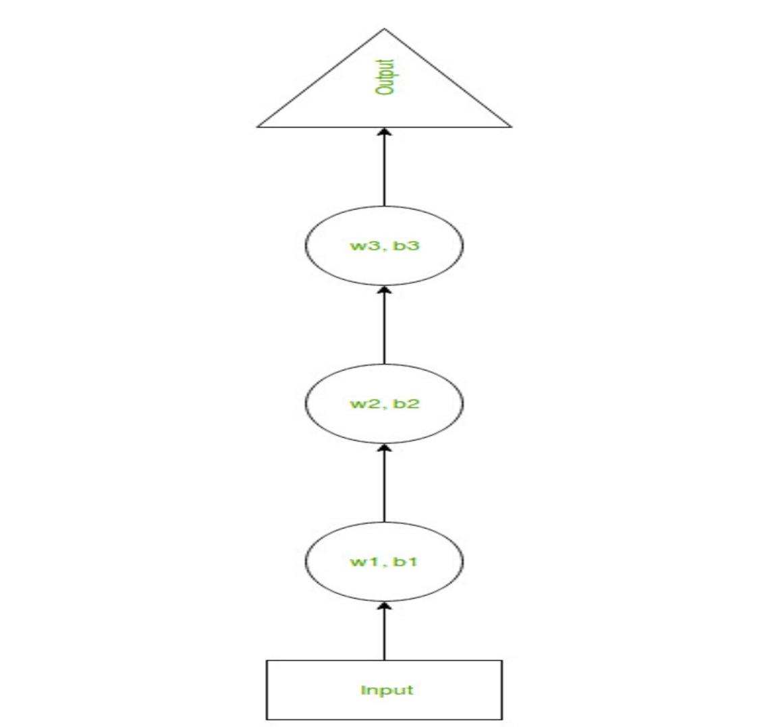

Figure 12: RNN with weights and biases

Now the RNN will do the following: -

* RNN coverts the independent activations in to dependent activations by providing the same weights and biases to all the layers, thus reducing complexity of increasing parameters and memorizing each previous output by giving each output as input to the next hidden layer.
* Hence, these three layers can be joined together such that weights and biases of all the hidden layers is the same in to a single recurrent layer.

**3.3 TRAINING THROUGH RNN:**

1. A single time step of the input is provided to the network
2. Then calculate its current state using set of current input and the previous state.
3. The current
4. One can go as many time steps according to the problem and join the information from all previous states.
5. Once all the time steps are completed the final current state is used to calculate the output.
6. The output is then compared to the actual output therefore the target output and the error is generated.
7. The error is then Backpropagated to the network to update the weights and hence the network RNN is trained.

**3.4 ADVANTAGES OF RNN:**

* An RNN remembers each and every information through time. It is useful in time series prediction only because of the feature to remember previous input as well. This is called Long Short-Term Memory (LSTM).
* RNN are even used with convolutional layers to extend the effective pixel neighbourhood.

**3.5 DISADVANATGES OF RNN:**

* Training an RNN is a very difficult task.
* It cannot process very long sequence if using tanh (or) as an activation function.